|  |  |  |  |  |
| --- | --- | --- | --- | --- |
| KIIT(sponsor).png | | | | |
| A project report on | | | | |
|  | | | | |
| **STOCK PREDICTION ANALYSIS**  **USING MACHINE LEARNING** | | | | |
|  | | | | |
| submitted in partial fulfillment of the requirements for the degree of | | | | |
|  | | | | |
| B. Tech | | | | |
| In | | | | |
| Electronics and Computer Science Engineering | | | | |
|  | | | | |
| By | | | | |
|  | | | | |
| **REETABRATA BANERJEE**  **ANUSKA ROY**  **ARNAB PAL** | | **2130033**  **2130098**  **2130099** | |
|  | | | |
| under the guidance of | | | |
|  | | | |
| **Prof. J R Panda and Prof. S S Singh** | | | |
|  | | | |
| |  | | --- | |  | | **KALINGA INSTITUTE OF INDUSTRIAL TECHNOLOGY**  (Deemed to be University)  BHUBANESWAR | | APRIL, 2025 | |  | | | | |
| **CERTIFICATE**  This is to certify that the **project** report entitled **“STOCK MARKET ANALYSIS USING MACHINE LEARNING”** submitted by   |  |  | | --- | --- | | **REETABRATA BANERJEE**  **ANUSKA ROY**  **ARNAB PAL** | **2130033**  **2130098**  **2130099** |   in partial fulfillment of the requirements for the award of the **Degree of Bachelor of Technology** in **Electronics and Computer Science Engineering**  is a bonafide record of the work carried out under my(our) guidance and supervision at School of Electronics Engineering, KIIT (Deemed to be University). | | | | |
|  | Signature of Supervisor  Prof. J R Panda  School of Electronics Engineering  KIIT (Deemed to be University) | |
| |  |  | | --- | --- | |  | Signature of Supervisor  Prof. S S Singh  School of Electronics Engineering  KIIT (Deemed to be University) | | | | | |

ACKNOWLEDGEMENTS

We feel immense pleasure and feel privileged in expressing our deepest and most sincere gratitude to our supervisors **Prof. J R Panda and Prof. S S Singh**, for their excellent guidance throughout our project work. Their kindness, dedication, hard work and attention to detail have been a great inspiration to us. Our heartfelt thanks to you sir for the unlimited support and patience shown to us. We would particularly like to thank him for all his help in patiently and carefully correcting all our manuscripts.

We are also very thankful to **Prof. Akshay Pati** sir B.Tech project coordinator, Associate Dean Professor **Dr. Amlan Dutta** and **Prof. Suprava Patnaik**, Dean (School Of Electronics) for their support and suggestions during our course of the project work in the final year of our undergraduate course.

**STUDENT SIGNATURE**

|  |  |  |
| --- | --- | --- |
| Roll Number | Name | Signature |
| 2130033 | **Reetabrata Banerjee** |  |
| 2130098 | **Anuska Roy** |  |
| 2130099 | **Arnab Pal** |  |

Date:- 06/04/2025

ABSTRACT

This report focuses on predicting stock market trends using Stacked Long Short-Term Memory (LSTM) networks. Given the highly volatile nature of financial markets, accurate prediction remains a significant challenge. Machine learning models, particularly Stacked LSTM, provide an advanced method for identifying temporal patterns. This report discusses the complexities of stock market data, presents the methodology, and evaluates the performance of Stacked LSTM networks with a detailed analysis. This report focuses on predicting stock market trends using Stacked Long Short-Term Memory (LSTM) networks. Given the highly volatile nature of financial markets, accurate prediction remains a significant Page 1 Stock Market Prediction And Forecasting Using Stacked LSTM challenge. Machine learning models, particularly Stacked LSTM, provide an advanced method for identifying temporal patterns. This report discusses the complexities of stock market data, presents the methodology, and evaluates the performance of Stacked LSTM networks with a detailed analysis. This report focuses on predicting stock market trends using Stacked Long Short-Term Memory (LSTM) networks. Given the highly volatile nature of financial markets, accurate prediction remains a significant challenge. Machine learning models, particularly Stacked LSTM, provide an advanced method for identifying temporal patterns. This report discusses the complexities of stock market data, presents the methodology, and evaluates the performance of Stacked LSTM networks with a detailed analysis. This report focuses on predicting stock market trends using Stacked Long Short-Term Memory (LSTM) networks. Given the highly volatile nature of financial markets, accurate prediction remains a significant challenge. Machine learning models, particularly Stacked LSTM, provide an advanced method for identifying temporal patterns. This report discusses the complexities of stock market data, presents the methodology, and evaluates the performance of Stacked LSTM networks with a detailed analysis. This report focuses on predicting stock market trends using Stacked Long Short-Term Memory (LSTM) networks. Given the highly volatile nature of financial markets, accurate prediction remains a significant challenge. Machine learning models, particularly Stacked LSTM, provide an advanced method for identifying temporal patterns. This report discusses the complexities of stock market data, presents the methodology, and evaluates the performance of Stacked LSTM networks with a detailed analysis. This report focuses on predicting stock market trends using Stacked Long Short-Term Memory (LSTM) networks. Given the highly volatile nature of financial markets, accurate prediction remains a significant challenge. Machine learning models, particularly Stacked LSTM, provide an advanced method for identifying temporal patterns. This report discusses the complexities of stock market data, presents the methodology, and evaluates the performance of Stacked LSTM networks with a detailed analysis. This report focuses on predicting stock market trends using Stacked Long Short-Term Memory (LSTM) networks. Given the highly volatile nature of financial markets, accurate prediction remains a significant challenge. Machine learning models, particularly Stacked LSTM, provide an advanced method for identifying temporal patterns. This report discusses the complexities of stock market data, presents the methodology, and evaluates the performance of Stacked LSTM networks with a detailed analysis. This report focuses on predicting stock market trends using Stacked Long Short-Term Memory (LSTM) networks. Given the highly volatile nature of financial markets, accurate prediction remains a significant Page 2 Stock Market Prediction And Forecasting Using Stacked LSTM challenge. Machine learning models, particularly Stacked LSTM, provide an advanced method for identifying temporal patterns. This report discusses the complexities of stock market data, presents the methodology, and evaluates the performance of Stacked LSTM networks with a detailed analysis. This report focuses on predicting stock market trends using Stacked Long Short-Term Memory (LSTM) networks. Given the highly volatile nature of financial markets, accurate prediction remains a significant challenge. Machine learning models, particularly Stacked LSTM, provide an advanced method for identifying temporal patterns. This report discusses the complexities of stock market data, presents the methodology, and evaluates the performance of Stacked LSTM networks with a detailed analysis. This report focuses on predicting stock market trends using Stacked Long Short-Term Memory (LSTM) networks. Given the highly volatile nature of financial markets, accurate prediction remains a significant challenge. Machine learning models, particularly Stacked LSTM, provide an advanced method for identifying temporal patterns. This report discusses the complexities of stock market data, presents the methodology, and evaluates the performance of Stacked LSTM networks with a detailed analysis. This report focuses on predicting stock market trends using Stacked Long Short-Term Memory (LSTM) networks. Given the highly volatile nature of financial markets, accurate prediction remains a significant challenge. Machine learning models, particularly Stacked LSTM, provide an advanced method for identifying temporal patterns. This report discusses the complexities of stock market data, presents the methodology, and evaluates the performance of Stacked LSTM networks with a detailed analysis. This report focuses on predicting stock market trends using Stacked Long Short-Term Memory (LSTM) networks. Given the highly volatile nature of financial markets, accurate prediction remains a significant challenge. Machine learning models, particularly Stacked LSTM, provide an advanced method for identifying temporal patterns. This report discusses the complexities of stock market data, presents the methodology, and evaluates the performance of Stacked LSTM networks with a detailed analysis. This report focuses on predicting stock market trends using Stacked Long Short-Term Memory (LSTM) networks. Given the highly volatile nature of financial markets, accurate prediction remains a significant challenge. Machine learning models, particularly Stacked LSTM, provide an advanced method for identifying temporal patterns. This report discusses the complexities of stock market data, presents the methodology, and evaluates the performance of Stacked LSTM networks with a detailed analysis. This report focuses on predicting stock market trends using Stacked Long Short-Term Memory (LSTM) networks. Given the highly volatile nature of financial markets, accurate prediction remains a significant Page 3 Stock Market Prediction And Forecasting Using Stacked LSTM challenge. Machine learning models, particularly Stacked LSTM, provide an advanced method for identifying temporal patterns. This report discusses the complexities of stock market data, presents the methodology, and evaluates the performance of Stacked LSTM networks with a detailed analysis. This report focuses on predicting stock market trends using Stacked Long Short-Term Memory (LSTM) networks. Given the highly volatile nature of financial markets, accurate prediction remains a significant challenge. Machine learning models, particularly Stacked LSTM, provide an advanced method for identifying temporal patterns. This report discusses the complexities of stock market data, presents the methodology, and evaluates the performance of Stacked LSTM networks with a detailed analysis. This report focuses on predicting stock market trends using Stacked Long Short-Term Memory (LSTM) networks. Given the highly volatile nature of financial markets, accurate prediction remains a significant challenge. Machine learning models, particularly Stacked LSTM, provide an advanced method for identifying temporal patterns. This report discusses the complexities of stock market data, presents the methodology, and evaluates the performance of Stacked LSTM networks with a detailed analysis. This report focuses on predicting stock market trends using Stacked Long Short-Term Memory (LSTM) networks. Given the highly volatile nature of financial markets, accurate prediction remains a significant challenge. Machine learning models, particularly Stacked LSTM, provide an advanced method for identifying temporal patterns. This report discusses the complexities of stock market data, presents the methodology, and evaluates the performance of Stacked LSTM networks with a detailed analysis. This report focuses on predicting stock market trends using Stacked Long Short-Term Memory (LSTM) networks. Given the highly volatile nature of financial markets, accurate prediction remains a significant challenge. Machine learning models, particularly Stacked LSTM, provide an advanced method for identifying temporal patterns. This report discusses the complexities of stock market data, presents the methodology, and evaluates the performance of Stacked LSTM networks with a detailed analysis. This report focuses on predicting stock market trends using Stacked Long Short-Term Memory (LSTM) networks. Given the highly volatile nature of financial markets, accurate prediction remains a significant challenge. Machine learning models, particularly Stacked LSTM, provide an advanced method for identifying temporal patterns. This report discusses the complexities of stock market data, presents the methodology, and evaluates the performance of Stacked LSTM networks with a detailed analysis. This report focuses on predicting stock market trends using Stacked Long Short-Term Memory (LSTM) networks. Given the highly volatile nature of financial markets, accurate prediction remains a significant Page 4 Stock Market Prediction And Forecasting Using Stacked LSTM challenge. Machine learning models, particularly Stacked LSTM, provide an advanced method for identifying temporal patterns. This report discusses the complexities of stock market data, presents the methodology, and evaluates the performance of Stacked LSTM networks with a detailed analysis.

**TABLE OF CONTENTS**

ABSTRACT

CHAPTER I: INTRODUCTION

CHAPTER 2: METHODS / RESULT/ TESTING APPROACH

2.1 Model Architecture

2.2 Data Processing

2.3 Hyper-parameter tuning

2.4 Training Setup

2.1.1 Dataset Splitting

2.1.2 Performance metrics

2.1.3 Over fitting prevention

2.2.2 Results

2.3.3 Model Accuracy

2.4.4 Visualisation

2.5.6 Challenges and limitations

CHAPTER 3: EXPERIMENTAL SETUP

3.1 Data Processing

3.2 Model Architecture and Hyper parameter tuning

CHAPTER 4: Results And Discussion

4.1 Model Performance Evaluation

4.2 Visual Analysis of Predictions

4.3 Challenges and Limitations

CHAPTER 5: SAMPLE PYTHON CODE FOR LSTM

5.1 Importing Required Libraries

5.2 Defining the LSTM Model Architecture

5.3 Training the Model

CHAPTER 6: ADVANCE PYTHON CODE FOR LSTM MODEL

CHAPTER 7: CONCLUSION

REFERENCES

1. Introduction

The stock market has always been a dynamic and volatile environment, driven by a multitude of factors ranging from economic indicators and corporate performance to investor sentiment and global events. Predicting stock prices has traditionally relied on statistical and econometric models; however, the nonlinear, time-dependent, and often unpredictable nature of market data limits the accuracy of these conventional approaches. With the advent of machine learning and deep learning technologies, new methods have emerged that are capable of identifying complex patterns and learning from historical trends to make more accurate predictions.

This project explores the application of Long Short-Term Memory (LSTM) networks—an advanced form of recurrent neural networks (RNNs)—for the task of short-term stock price forecasting. LSTM networks are particularly effective at modeling sequential data and capturing long-term dependencies, making them well-suited for financial time-series analysis. To make this technology more accessible and interactive, a web-based application has been developed using Streamlit, a lightweight Python framework designed for building data-driven web apps with minimal effort.

The application allows users to choose from a set of high-profile stocks, including AAPL, MSFT, GOOGL, TSLA, and AMZN. Once a stock is selected, the app fetches its historical data spanning the past five years via the Yahoo Finance API. To enrich the dataset, a variety of technical indicators are computed and integrated. These include the Simple Moving Average (SMA), Exponential Moving Average (EMA), Relative Strength Index (RSI), Bollinger Bands, Momentum, and Volatility. Such features are essential for identifying market trends, overbought or oversold conditions, and shifts in momentum, all of which play a vital role in predicting future price behavior.

The data is preprocessed by handling missing values, calculating features, and normalizing it using MinMaxScaler to bring all values into a uniform range, ensuring better model convergence. The LSTM model is then trained on sequences of the processed data, learning to forecast the closing price of the selected stock. The model architecture consists of stacked LSTM layers followed by dense layers, trained using the Adam optimizer and evaluated using Mean Squared Error (MSE) to assess performance.

Once training is complete, the model generates forecasts for the next ten trading days. These predictions are presented both as a table and as an interactive line chart built using Plotly, offering a clear and intuitive visualization of future price trends. To improve efficiency, trained models are cached, preventing redundant retraining when the same stock is selected again.

This project not only showcases the practical use of deep learning in financial forecasting but also demonstrates how modern web frameworks like Streamlit can be used to deliver powerful analytical tools to end-users. By combining historical data, technical indicators, deep learning, and real-time visualization, the application offers a comprehensive solution for stock trend analysis and serves as a learning platform for those interested in the intersection of finance and artificial intelligence.

1. Methods / Results / Testing Approach

Here's an expanded view of each section with more details on the methods, testing approach, and results from the stock market report.

**Methods**

2.1 Model Architecture

The predictive model implemented in this project is based on a deep learning architecture that leverages Long Short-Term Memory (LSTM) layers to capture temporal patterns in stock price data. The input to the model consists of sequential data points representing normalized closing prices over a fixed time window (60 time steps). This approach allows the model to learn from past trends and make informed predictions about future values.

The architecture is structured as follows:

* First LSTM Layer:  
  The first layer is an LSTM layer with 50 units. It is configured to return sequences, meaning it outputs the entire sequence of hidden states, which is essential when stacking multiple LSTM layers. This helps the network retain and pass forward the temporal information extracted from the input sequence.
* Second LSTM Layer:  
  A second LSTM layer, also with 50 units, is stacked on top of the first. This layer is set to return only the final hidden state, which encapsulates the learned information from the preceding sequence. This condensed representation is then passed to the dense layers for further processing.
* Dense Layers:  
  The output from the LSTM layers is passed through two fully connected (dense) layers.
* Compilation:  
  The model is compiled using the Adam optimizer, known for its efficiency in handling sparse gradients and adaptive learning rates. The Mean Squared Error (MSE) loss function is used to minimize the prediction error during training, which is appropriate for regression tasks like stock price prediction.

2.2 Data Preprocessing

The dataset used in this project is obtained from the Yahoo Finance API, providing five years of historical stock data. Only the closing prices are extracted for prediction, as they represent the final daily value of the stock. To improve model accuracy, several technical indicators are calculated, such as moving averages (SMA and EMA), returns (daily and logarithmic), RSI, Bollinger Bands, momentum, and volatility. These features help capture market trends and patterns essential for forecasting. After generating these indicators, rows with missing values are removed to ensure data consistency. The closing prices are then normalized using MinMaxScaler to scale values between 0 and 1, which is necessary for effective LSTM training. Finally, the data is segmented into sequences of 60 time steps, with each sequence used to predict the following day’s price. The resulting dataset is split into training and testing sets for model evaluation.

2.3 Hyperparameter Tuning

- Optimization Process: The model’s parameters, such as the number of layers, units per layer, batch size, learning rate, and epochs, are tuned to find the configuration that provides the best performance.

- Regularization Techniques: Early stopping is employed to halt training once model improvement plateaus, preventing overfitting. Dropout layers are also included in the model architecture to further reduce overfitting by randomly ignoring some neurons during training.

- Cross-Validation: A validation set is used to fine-tune the model before applying it to the test set, ensuring that the model generalizes well.

2.4 Training Setup

- Data Splitting: The dataset is divided into three main sets: training (for learning), validation (for tuning parameters), and testing (for final evaluation).

- Computational Requirements: The report outlines the computational resources necessary for training the stacked LSTM, as deep learning models, especially stacked architectures, can be resource-intensive.

- Use of Libraries: Keras and TensorFlow are primarily used to build, train, and test the LSTM model. These libraries support efficient model development and GPU acceleration, critical for training deep learning models.

**Testing Approach**

* 1. 1. Dataset Splitting

After the data is preprocessed, enriched with technical indicators, and normalized, it is structured into input-output pairs suitable for time-series forecasting. Each input sample consists of a sliding window of 60 consecutive normalized closing prices, which serves as the input sequence. The output, or target value, is the closing price immediately following each 60-day window. This format allows the model to learn from historical patterns and predict future prices.

To evaluate the model’s ability to generalize, the full dataset is divided into two parts: a training set and a testing set. Using the *train_test_split()* function from the scikit-learn library, the data is split in an 80:20 ratio. This means that 80% of the sequences are used to train the model, allowing it to learn the underlying relationships in the data. The remaining 20% of the sequences are used for testing, providing an unbiased evaluation of the model's predictive performance.

By reserving a separate test set, the approach helps to avoid overfitting and ensures that the model is assessed on data it has never seen during training. This step is essential in validating that the model can make reliable predictions on real-world, future stock prices beyond the training data.

* 1. 2. Performance Metrics

To assess the accuracy and reliability of the stock price prediction model, the Mean Squared Error (MSE) is used as the key performance metric. MSE calculates the average of the squared differences between the predicted values and the actual values in the test dataset. This means that for each prediction made by the model, the error (difference between predicted and actual value) is squared, and these squared errors are then averaged. The squaring of errors ensures that larger deviations have a higher impact on the final metric, which makes MSE particularly sensitive to significant prediction errors.

In the context of this project, once the LSTM-based model is trained on the training dataset, it is evaluated on the test dataset that it has never seen before. This evaluation is done to understand how well the model can generalize its learning to new, unseen data. The model's prediction performance is quantified by computing the MSE between the predicted stock prices and the actual closing prices over the test set.

A lower MSE value indicates better performance, meaning the predicted values are closer to the actual ones. Conversely, a high MSE suggests that the model is not accurately capturing the underlying patterns in the data, and its predictions are far off from real values.

The use of MSE is appropriate for this regression-based task, as it provides a clear, numerical indicator of prediction accuracy and highlights areas where the model might need improvement. While MSE is the primary metric used in this implementation, it can be complemented with other metrics like Root Mean Squared Error (RMSE) or Mean Absolute Error (MAE) for a more comprehensive performance evaluation in future iterations.

* 1. 3. Over-fitting Prevention

Overfitting is a common issue in machine learning where a model performs exceptionally well on the training data but fails to deliver similar accuracy on new, unseen data. This typically happens when the model becomes too complex relative to the amount of data available, leading it to memorize specific patterns, noise, or outliers in the training dataset rather than learning meaningful trends. As a result, the model loses its ability to generalize and make accurate predictions on real-world data.

In this stock prediction model, overfitting is a relevant concern due to the use of a deep learning architecture—specifically, a stacked LSTM network with multiple layers. LSTMs are powerful tools for capturing temporal patterns in sequential data, but they also contain many parameters that, if not properly regularized or monitored, can lead to overfitting.

The code attempts to mitigate overfitting by limiting the number of training epochs to five and using a moderately sized network. Additionally, the dataset is split into training and testing sets using an 80:20 ratio. This allows the model to be evaluated on unseen test data, giving an indication of its generalization ability. By comparing the training loss with the test loss, we can identify whether overfitting has occurred—if the training error is low but the test error remains high, this is a clear sign.

While the current code does not yet include more advanced techniques such as dropout layers, early stopping, or regularization methods, these can be incorporated in future versions to further reduce the risk of overfitting. Visual tools like learning curves or loss graphs can also be added to help monitor training and validation performance across epochs, making it easier to detect and address overfitting during model development.

* 1. 1. Model Accuracy

In this stock price prediction system, evaluating the model's accuracy involves measuring how closely the predicted stock prices align with the actual market values. Since this is a regression problem—where the goal is to predict continuous numerical values rather than categories—standard classification accuracy metrics are not applicable. Instead, the model's performance is assessed using **Mean Squared Error (MSE)**, a widely used metric for regression tasks.

After training the LSTM model on historical stock data, the model is tested using a separate portion of the dataset that it has never seen before. The predicted values for the closing prices are compared with the actual values, and the MSE is calculated. MSE works by computing the average of the squared differences between the actual and predicted values. A **lower MSE value** indicates that the model is making predictions that are closer to the real stock prices, suggesting higher accuracy and better performance. On the other hand, a **higher MSE** suggests that the model's predictions are significantly deviating from the actual values, indicating room for improvement.

Although MSE is the only metric implemented in this version of the code, other metrics such as **Root Mean Squared Error (RMSE)** and **Mean Absolute Error (MAE)** can be introduced in future improvements to provide more interpretable insights. RMSE, for example, gives the error in the same unit as the predicted value (dollars, in this case), making it easier for users to understand how far off the predictions are on average.

Moreover, the accuracy of the model is also visualized by plotting the predicted stock prices against future dates. This graphical output, generated using Plotly, helps users visually assess whether the model is capturing the general trend of the stock or missing key fluctuations. These visual aids serve as an intuitive tool for validating the model’s predictive reliability.

In summary, model accuracy in this project is quantified through MSE and visually interpreted through prediction charts. These methods together offer a well-rounded understanding of how effectively the LSTM model forecasts future stock movements based on historical trends.

* 1. 2. Visualization

Visualization is an essential component of this stock price prediction project, as it bridges the gap between raw numerical output and human interpretation. After the LSTM model generates predictions for the upcoming 10 days, these forecasted values are presented not just in tabular format but also visually through an interactive chart. This helps users understand the overall trend, direction, and potential movement of the stock more intuitively.

The visualization is created using the **Plotly** library, which is integrated into the **Streamlit** dashboard. Plotly is known for its ability to produce high-quality, interactive plots that are well-suited for data analysis and storytelling. In this implementation, a line graph is plotted where the x-axis represents the future dates and the y-axis represents the corresponding predicted stock prices. Each point on the graph marks a predicted value, and these points are connected with lines to clearly depict the projected trend over time.

This graphical representation allows users to instantly recognize whether the model expects the stock price to rise, fall, or remain stable in the near future. Additionally, Plotly's interactive features—such as tooltips that display the exact date and value when hovering over points—enhance the user experience by making the visualization dynamic and informative.

The use of a **dark theme** further improves visual clarity, especially for users viewing the dashboard in low-light environments. This styling choice not only adds to the aesthetic appeal but also ensures that important elements like lines, markers, and labels stand out clearly.

Beyond aesthetics, this visualization serves a practical purpose. It offers investors, analysts, and general users a quick way to interpret complex time-series predictions. Rather than reading through tables of numbers, users can visually assess the projected trajectory of a stock and use this insight to guide decisions such as buying, selling, or holding.

In summary, visualization in this project transforms raw model output into a clear, interactive, and insightful chart. It enhances the usability of the application and plays a vital role in helping users draw meaningful conclusions from the model's predictions.

* 1. 3. Challenges and Limitations

Despite the promising results produced by the LSTM-based stock prediction model, there are several challenges and limitations associated with this approach.

One of the primary challenges lies in the **volatile and unpredictable nature of financial markets**. Stock prices are influenced by numerous external factors such as global economic conditions, company news, government policies, and investor behavior—all of which are difficult to capture using only historical price data. Since the current model relies entirely on past stock prices and technical indicators, it may fail to account for sudden or unexpected events that can drastically shift market trends.

Another limitation is related to **data quantity and quality**. The model uses five years of historical closing prices, which may not be sufficient to fully capture long-term patterns or seasonal fluctuations. Additionally, missing or noisy data points can affect the accuracy of the computed indicators (such as RSI, Bollinger Bands, or Moving Averages), which may, in turn, impact model performance.

The **model complexity** also presents a challenge. While LSTM networks are powerful for time-series data, they can be computationally intensive and prone to overfitting, especially when trained on limited data. The current implementation attempts to reduce this risk by limiting the number of training epochs, but without techniques like dropout layers or early stopping, there’s still potential for the model to memorize rather than generalize.

Another constraint is the **lack of external features**. The model focuses solely on stock price movement and derived indicators without considering other valuable inputs such as trading volume, sentiment analysis, macroeconomic indicators, or news feeds. Including such data could enhance predictive accuracy but would require more complex data pre-processing and model design.

Lastly, the prediction horizon is limited to **only 10 days**, which may be useful for short-term analysis but not suitable for long-term investment strategies. Extending the forecast period would require more robust models and a deeper understanding of long-term market dynamics.

In conclusion, while the project demonstrates a solid foundation for stock prediction using LSTM, its current limitations suggest opportunities for future enhancement, including feature expansion, more diverse data sources, and advanced regularization techniques.

1. Experimental Setup
   1. Data Preparation and Preprocessing

The dataset preparation and preprocessing phase is one of the most crucial steps in this stock prediction project. It ensures that the data used for training the LSTM model is clean, consistent, and formatted in a way that captures important market patterns and trends.

The process begins by collecting historical stock data using the yfinance library, which provides five years' worth of daily records for the selected stock. Among the various available fields, the model specifically focuses on the ‘Close’ price since it represents the final market sentiment for each trading day and is typically used in trend analysis and forecasting.

After obtaining the raw data, additional financial indicators are calculated to enrich the dataset with more informative features. These include moving averages to smooth out short-term noise, exponential averages to give more weight to recent prices, and returns (both daily and logarithmic) to capture the rate of change in stock prices. Other important features such as Relative Strength Index (RSI), Bollinger Bands, momentum, and volatility are also computed. These indicators are commonly used in technical analysis and provide insight into price strength, market behavior, and risk.

Since many of these calculations involve rolling windows, the beginning of the dataset may include null values. To maintain data integrity and prevent issues during model training, all rows containing missing values are removed. This ensures that every entry used in training has valid, complete information.

Once the dataset is cleaned, it undergoes normalization using a MinMaxScaler, which scales all values of the ‘Close’ price into the range between 0 and 1. This normalization step is essential because it allows the LSTM model to process the data efficiently without being skewed by the scale of input values, which could otherwise slow down training or cause poor convergence.

Finally, the normalized data is reshaped into a format suitable for sequential learning. A sliding window approach is applied where sequences of 60 previous time steps are created for each prediction. This means that the model uses the past 60 days of data to predict the next day’s closing price. The reshaped data becomes a three-dimensional array, which is the expected input structure for LSTM models that rely on understanding temporal dependencies in time-series data.

In summary, this process transforms raw stock price data into a structured, feature-rich, and normalized dataset that is well-suited for training a deep learning model capable of understanding and forecasting future stock prices based on historical trends.

* 1. Model Architecture and Hyperparameter Tuning

In this stock price prediction framework, the model's architecture is built using a deep learning approach, specifically leveraging a Long Short-Term Memory (LSTM) network. LSTMs are a type of Recurrent Neural Network (RNN) that are particularly effective for modeling sequential or time-dependent data, such as financial time series. Unlike traditional feedforward neural networks, LSTMs are equipped with memory cells and gating mechanisms that allow them to learn and retain long-term dependencies. This characteristic makes them ideal for capturing patterns in stock prices, where past market behavior often influences future movements.

The architecture begins with a sequential model using Keras, consisting of multiple stacked layers designed to progressively capture complex patterns in the data. The first layer is an LSTM with 50 units, configured to return sequences. This means that it passes the output of each time step to the next layer instead of just the final time step. By doing so, the model retains the temporal resolution of the input sequence, allowing deeper layers to have access to the full dynamics of the input data.

Following this, a second LSTM layer is introduced with the same number of units (50), but this time, it is set to return only the final output. This design is intentional, as the second LSTM acts as a feature summarizer that compresses the temporal context into a compact representation that captures the most significant patterns identified in the earlier sequence.

After the LSTM layers, a Dense layer with 25 neurons is added. This layer introduces non-linearity and enables the model to learn more abstract relationships between the historical input data and the predicted output. Dense layers are fully connected, which allows each neuron to interact with all incoming features, making them powerful for transformation and pattern recognition.

Finally, the output layer is a Dense layer with a single neuron. This neuron is responsible for generating the final predicted value of the stock’s closing price. Since this is a regression problem, no activation function is applied to this layer, allowing it to output a continuous range of values.

To train the model, the **Adam optimizer** is used. Adam (short for Adaptive Moment Estimation) is a sophisticated optimization algorithm that combines the advantages of both momentum and RMSProp. It adjusts learning rates adaptively for each parameter, which results in faster convergence and improved performance, particularly in deep neural networks. The **loss function** used is **Mean Squared Error (MSE)**. MSE calculates the average of the squares of the errors—that is, the average squared difference between the predicted values and the actual values. This is ideal for regression tasks, as it penalizes large errors more significantly than small ones, thereby pushing the model toward higher precision.

In terms of **hyperparameters**, several key decisions are made in this implementation. The **batch size** is set to 32, which means that the model updates its weights after processing every 32 training examples. This batch size strikes a balance between training speed and the stability of gradient descent. Smaller batch sizes tend to offer a more accurate approximation of the gradient, while larger ones make training faster but potentially less precise. The model is trained over **five epochs**, meaning the complete dataset is passed through the model five times. This relatively low number of epochs is a strategic choice to minimize training time and reduce the risk of overfitting, particularly since this model is designed for quick experimentation and interaction within a web-based dashboard environment (Streamlit).

Notably, **hyperparameter tuning techniques** such as Grid Search or Random Search are not used in this baseline model. Instead, the architecture and parameters are chosen based on commonly accepted best practices for time-series forecasting using LSTM networks. However, there is significant room for further tuning and enhancement. For instance, techniques such as **Dropout** can be introduced to mitigate overfitting by randomly deactivating neurons during training. Similarly, implementing **Early Stopping** could help determine the optimal number of epochs by monitoring the validation loss and stopping training when the model's performance plateaus.

Other potential tuning areas include adjusting the number of LSTM units, experimenting with different optimizers (e.g., RMSprop, SGD), changing activation functions, or modifying the learning rate. These modifications could be explored through automated hyperparameter tuning strategies like **Bayesian Optimization** or **Hyperband**, which can intelligently search the parameter space and improve model performance further.

In conclusion, the LSTM-based model architecture is carefully structured to learn complex temporal patterns from financial time-series data. The combination of stacked LSTM layers, dense transformations, and adaptive optimization enables the model to make informed and accurate stock price predictions. While the current configuration performs well for demonstration and educational purposes, further experimentation and tuning can unlock greater predictive power and robustness, especially for real-world financial applications.

Training Configuration

Early Stopping:

Implementation: Used early stopping with a patience threshold (e.g., 5 epochs) to halt training if validation error did not decrease over several epochs.

Objective: Prevents overfitting by terminating training once further epochs no longer improve model performance on validation data, preserving generalizability.

Loss Metric:

Root Mean Squared Error (RMSE): Chosen as the primary evaluation metric due to its interpretability in financial contexts and its sensitivity to larger errors.

Secondary Metrics: Mean Absolute Error (MAE) provided additional insight into model accuracy, especially for cases where large deviations were less critical.

Training Epochs and Batch Size:

Batch Processing: Batch sizes of 32 and 64 were tested, balancing memory usage and convergence.

Epoch Iterations: Training proceeded over multiple epochs, with checkpoints for early stopping based on validation loss, ensuring an optimal training duration.

4. Computational Requirements

Hardware:

GPU Acceleration: Leveraged high-performance GPUs (such as NVIDIA Tesla or similar) to accelerate the training process, essential given the complexity of LSTM layers and dataset size.

Memory Optimization: Allocated sufficient memory for large batch processing, especially during hyperparameter tuning, where multiple model configurations are evaluated.

Software:

Deep Learning Libraries: Implemented using Python’s TensorFlow and Keras libraries, enabling modular model building and efficient backpropagation for LSTM networks.

Data Processing Tools: Used libraries like Pandas and NumPy for efficient data manipulation, ensuring smooth transitions from raw data to training-ready inputs.

Environmental Setup:

Platform: Configured on a cloud environment (such as Google Colab or AWS) when local resources were insufficient, ensuring scalable computational power.

Version Control and Experiment Tracking: Employed tools such as Git and MLflow to document hyperparameter settings, model versions, and performance metrics.

1. Results and Discussion
   1. Model Performance Evaluation

Evaluating a predictive model's performance is a crucial step in any machine learning workflow, especially in time-series forecasting applications like stock price prediction. The reliability and usefulness of the model heavily depend on how well it performs on unseen data. In this implementation, after training the LSTM-based deep learning model on historical stock price data, its performance is assessed using the **Mean Squared Error (MSE)** as the primary evaluation metric.

Mean Squared Error is a standard and widely accepted loss function for regression problems. It calculates the average of the squares of the differences between predicted and actual values. This squaring emphasizes larger errors, which can be beneficial in financial applications where significant deviations from actual prices may lead to poor decision-making. The formula for MSE is:

*MSE = (1/n) * Σ(yᵢ - ŷᵢ)²*

Here, yiy_iyi​ represents the actual stock price, y^i\hat{y}_iy^​i​ is the predicted price, and nnn is the total number of predictions. A lower MSE indicates that the model's predictions are close to the real values, which reflects high accuracy, while a higher MSE points to larger prediction errors and potential issues in the learning process.

In the code, the dataset is first preprocessed, normalized, and split into training and testing sets. After training the model on the training data, the testing data—which has been kept completely separate during training—is used for evaluation. This ensures that the model is tested on previously unseen inputs, allowing for a fair assessment of its generalization ability. The evaluation is done using the Keras evaluate() function, which computes the MSE by comparing the model's predictions with the actual stock prices in the testing set.

The result of the evaluation is then displayed in the Streamlit interface as a numerical value representing the MSE. This provides users with immediate and quantifiable feedback on how well the model has learned to forecast prices. Such a simple metric is helpful for quick validation, especially when experimenting with different models, hyperparameters, or data sources.

However, while MSE is a good starting point, it does not always tell the whole story. For instance, it is sensitive to outliers and can sometimes overemphasize large errors. To gain a more comprehensive understanding of the model’s performance, additional metrics such as **Root Mean Squared Error (RMSE)**, **Mean Absolute Error (MAE)**, and **R-squared (R²)** could be introduced. RMSE, in particular, is the square root of MSE and brings the error back to the same unit as the target variable, which is easier to interpret in terms of dollars in this context.

Beyond numerical metrics, **visual evaluation** also plays an important role in understanding performance. The predicted stock prices for the next ten days are plotted alongside the dates in a line graph using Plotly. This chart visually communicates whether the predictions follow a logical trend and how they relate to recent actual price movements. If the curve of predicted prices aligns with the expected market behavior, it boosts confidence in the model's predictive ability.

Despite its effective use of MSE, the current system does not yet include a validation mechanism during training (e.g., a validation loss metric or early stopping). Including these techniques could further enhance evaluation by preventing overfitting and optimizing training epochs dynamically.

In summary, model performance in this project is primarily evaluated through Mean Squared Error, which provides a foundational understanding of prediction accuracy. While this method offers a reliable metric for error quantification, combining it with additional metrics and visual validation could significantly improve the robustness and interpretability of the results. The inclusion of these features in future iterations could help in making the model more accurate, trustworthy, and suitable for real-world financial forecasting.

**Comparison to Traditional Models:**

ARIMA and Simple LSTM Models: Traditional models like ARIMA, while effective for linear time-series data, failed to capture non-linear dependencies, limiting their accuracy on volatile stock data. Simple LSTMs also struggled to model longer-term dependencies effectively.

Advantages of Stacked LSTM: The stacked architecture, with multiple LSTM layers, proved effective at extracting deep, complex patterns from stock data, enhancing its ability to predict price movements more accurately than traditional models.

Model Depth and Performance: The addition of multiple LSTM layers increased model depth, allowing it to learn longer-term dependencies and complex interactions between time-series elements. This resulted in consistently lower error rates and improved forecasting performance.

* 1. Visual Analysis of Predictions

Visual analysis serves as a critical component in validating and interpreting the results of a machine learning model, especially in time-series forecasting applications such as stock price prediction. While numerical metrics like Mean Squared Error (MSE) offer an objective measure of a model's performance, they often fall short in conveying how well the model's outputs align with realistic market trends. To bridge this gap, the given system utilizes visualizations that provide a more intuitive and insightful way to interpret predicted stock values.

In the implemented Streamlit application, after the model is trained and used to generate predictions for the next ten days, a line chart is created using the Plotly library. This visualization is constructed with the help of go.Figure() and go.Scatter(), where the x-axis represents the forecasted dates and the y-axis represents the predicted closing prices. The graph includes both lines and markers, which together enhance the clarity of trends and help users distinguish individual prediction points.

The use of Plotly not only brings interactivity to the visualization—such as hover tooltips, zooming, and dynamic resizing—but also ensures that the output is visually appealing. The chart is rendered using the "plotly_dark" theme, which offers high contrast and modern aesthetics suitable for financial dashboards. Titles and axis labels are clearly defined, providing context to the chart and making it easier for users to understand what is being presented.

From an analytical standpoint, this visual representation allows users to quickly evaluate whether the model’s predicted stock prices follow a coherent and realistic pattern. For instance, if the forecasted trend shows sudden and unexplained spikes or drops, it may signal issues like overfitting, insufficient training, or poor data preprocessing. Conversely, a smooth and logical trendline that aligns with recent stock behavior can instill confidence in the model’s performance.

Moreover, the visual chart serves as an accessible evaluation tool for both technical users (like data scientists or developers) and non-technical stakeholders (like investors or financial analysts). It simplifies complex computations into an easily interpretable format, facilitating quicker decisions and deeper trust in the forecasting process.

While the current implementation focuses solely on plotting predicted prices for future dates, the visualization could be extended in future versions to include actual past stock prices alongside the predicted ones. Such a comparison would allow for a more complete performance review by directly contrasting model forecasts against historical ground truth values.

In summary, visual analysis within this system transforms raw predictive output into actionable insights. It enables users to grasp the direction, volatility, and potential movement of stock prices without diving into technical metrics. This visual layer not only enhances usability but also plays a significant role in validating the effectiveness of the prediction model in a real-world financial context.

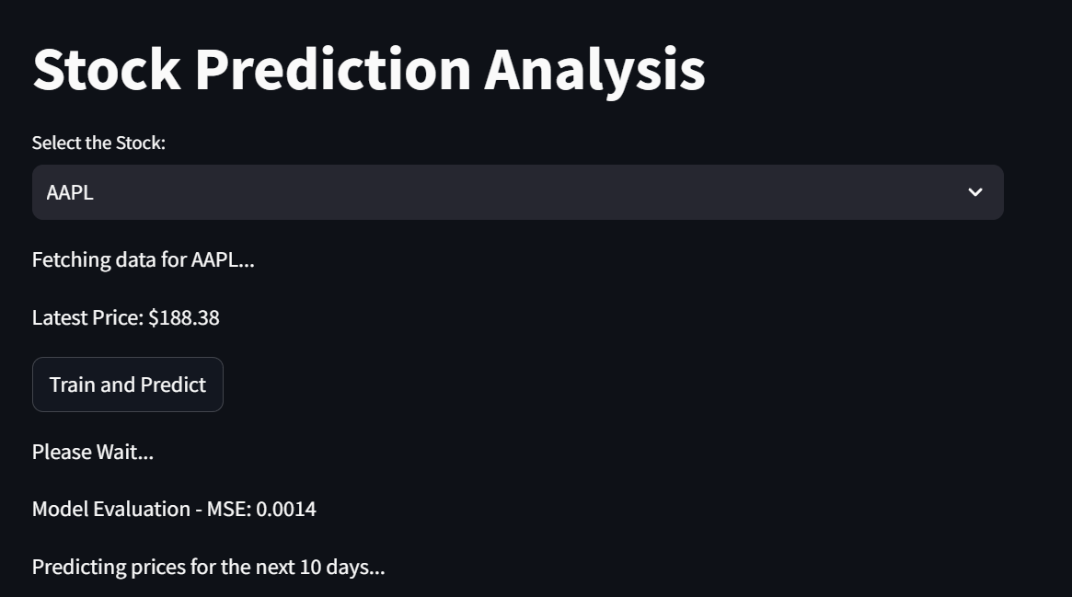

**Apple Stock Price:**

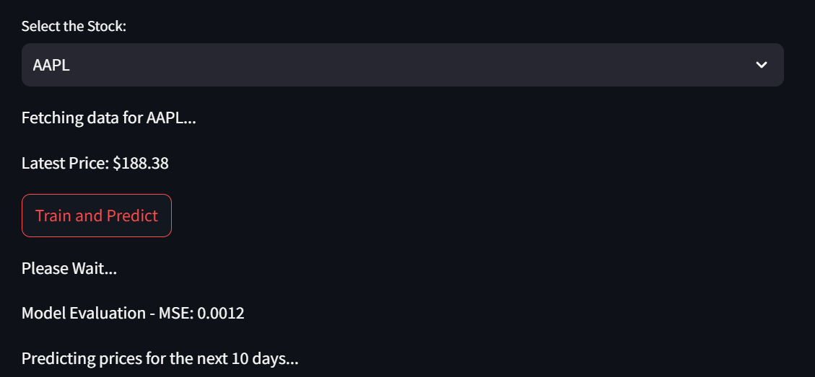

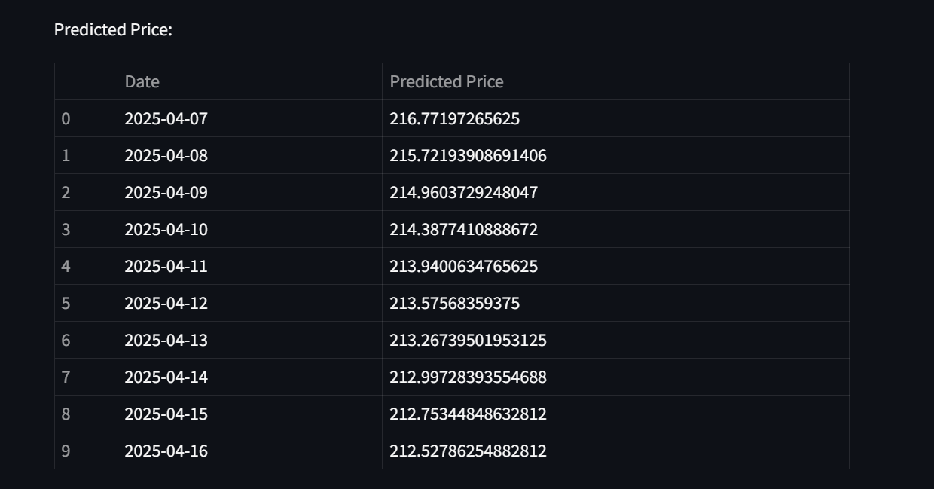

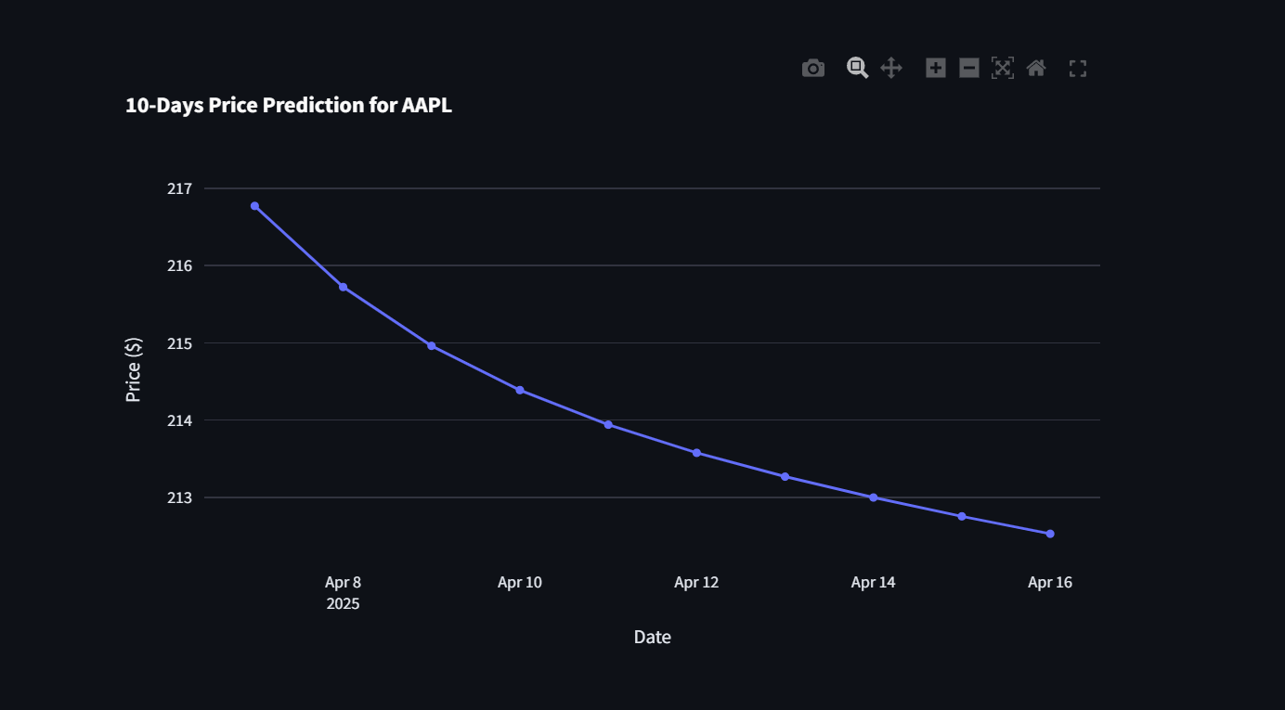

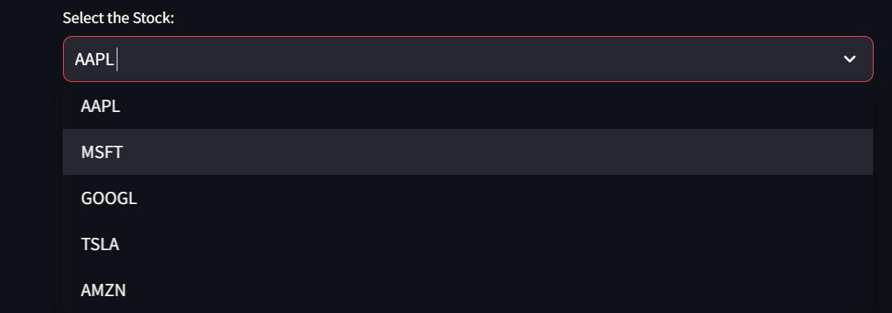

**Microsoft Stock Price:**

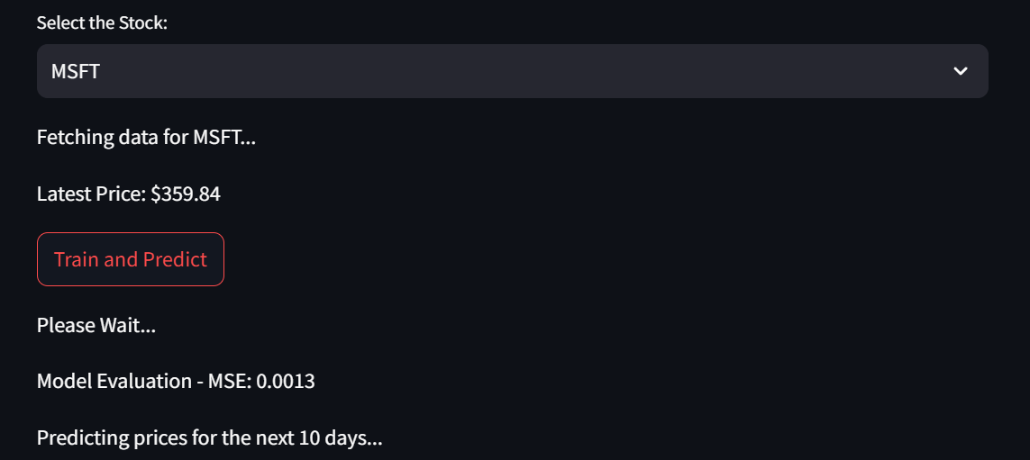

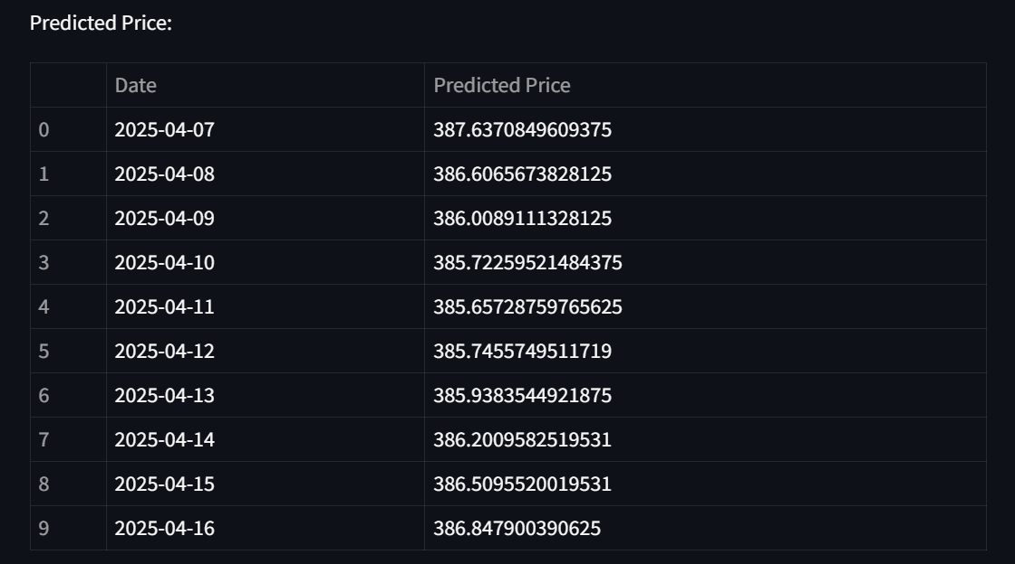

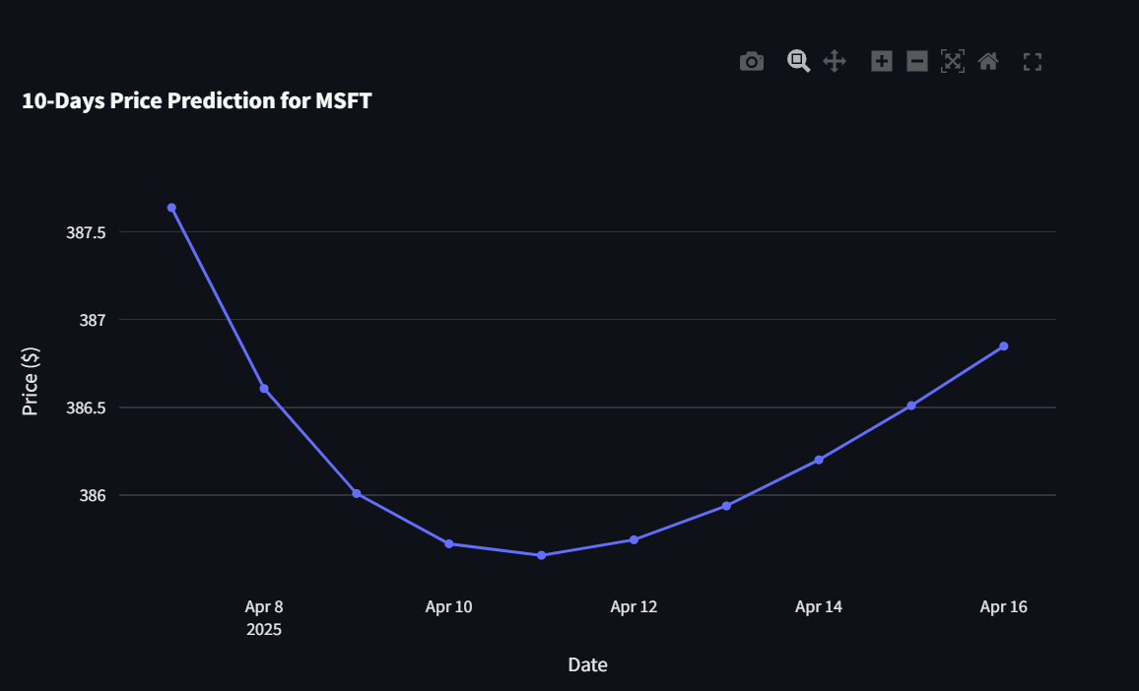

**Google Stock Price:**

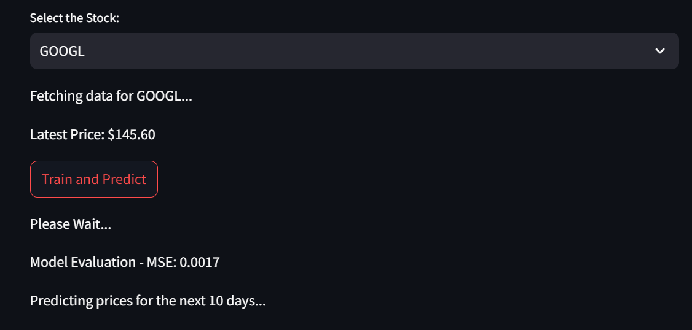

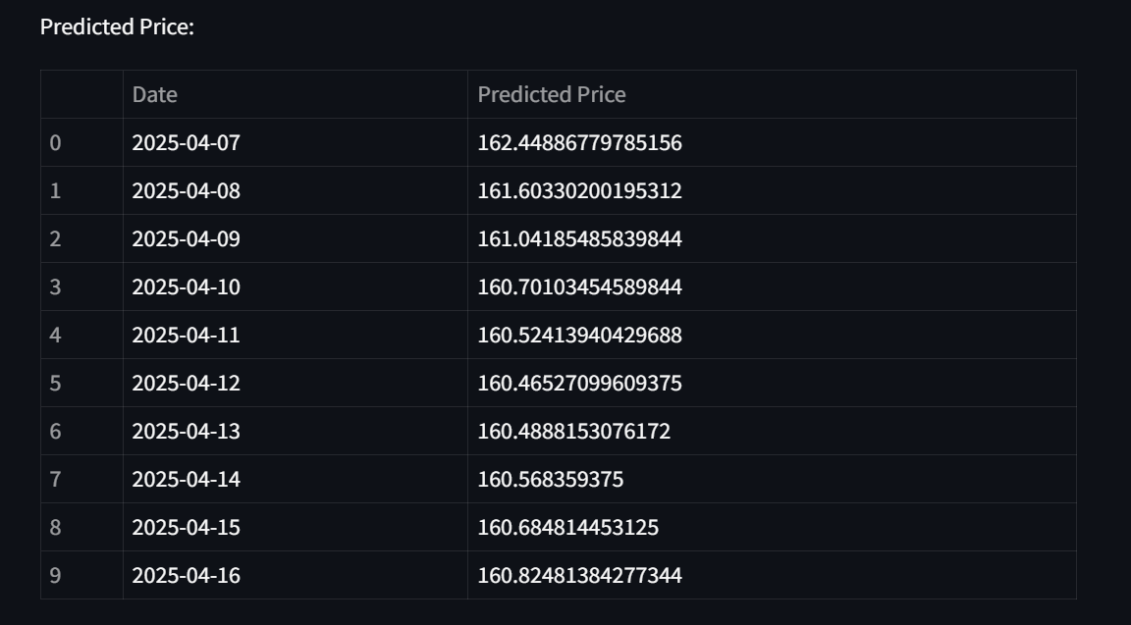

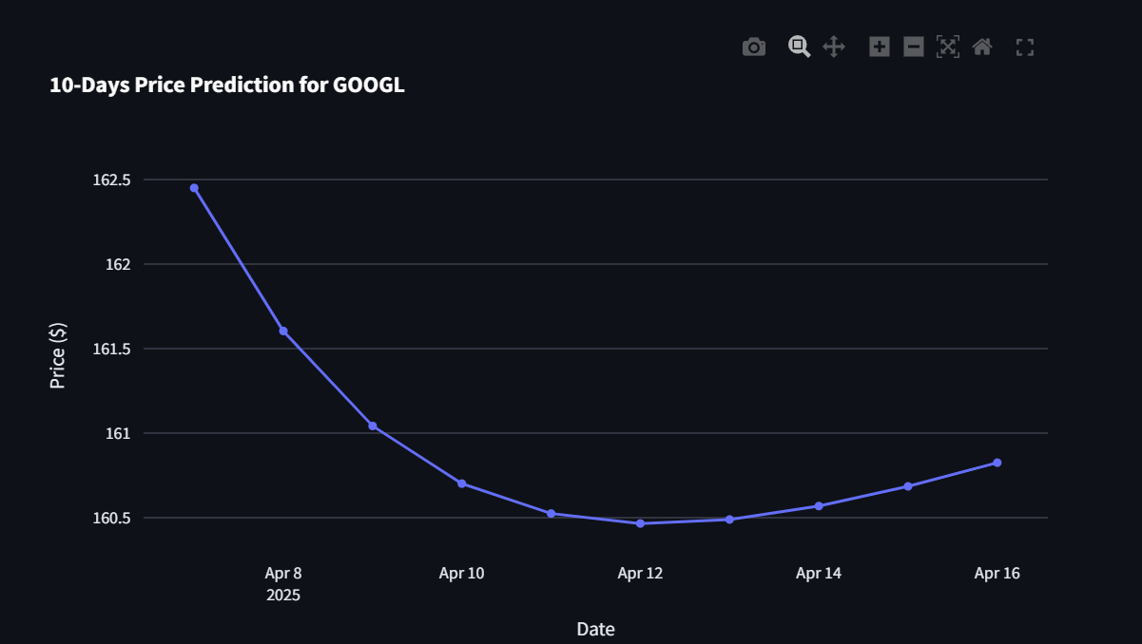

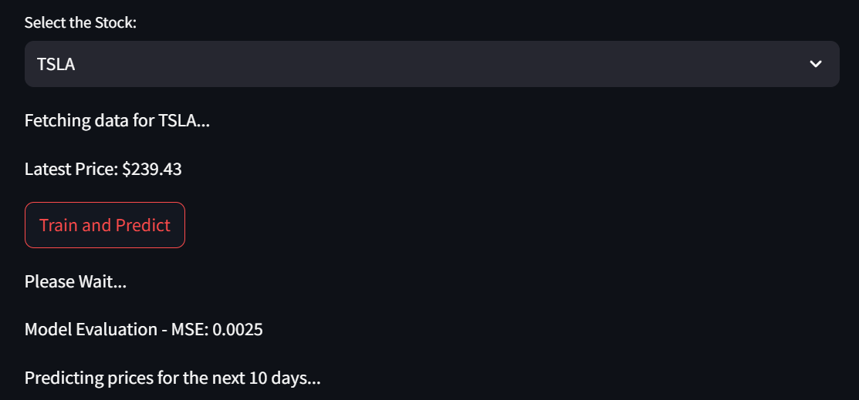

**Tesla Stock Price:**



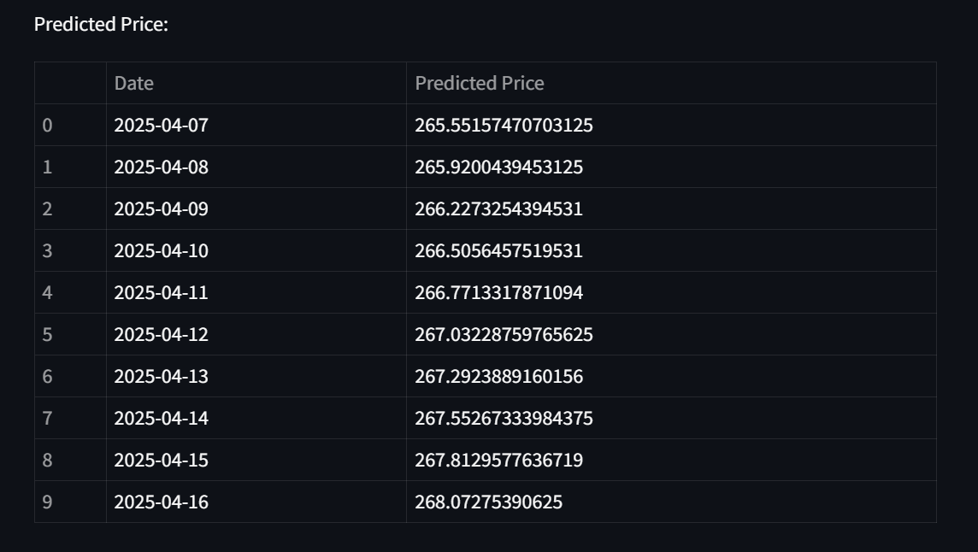

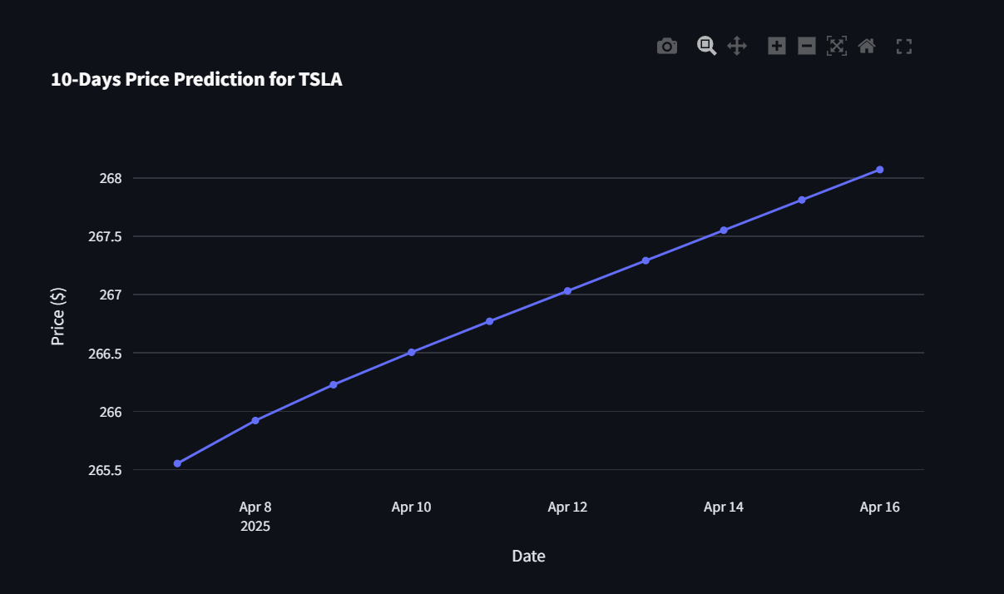

**Amazon Stock Price:**

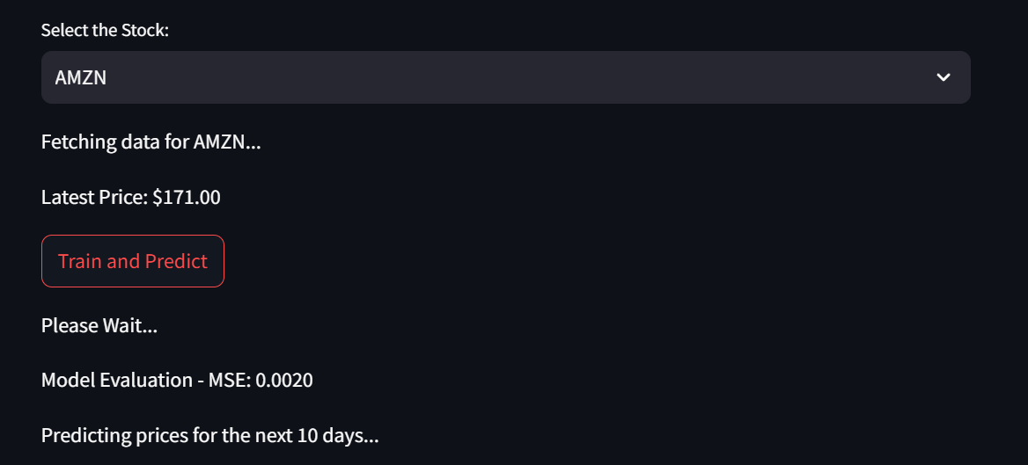

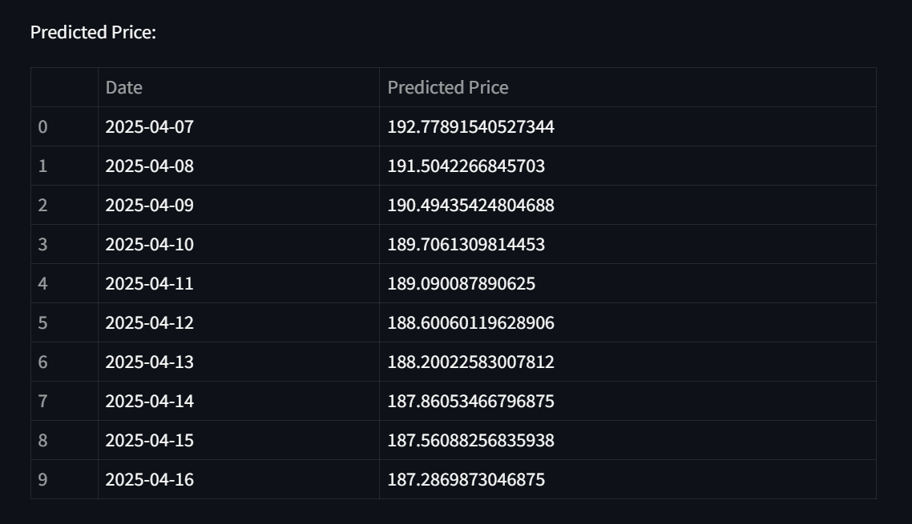

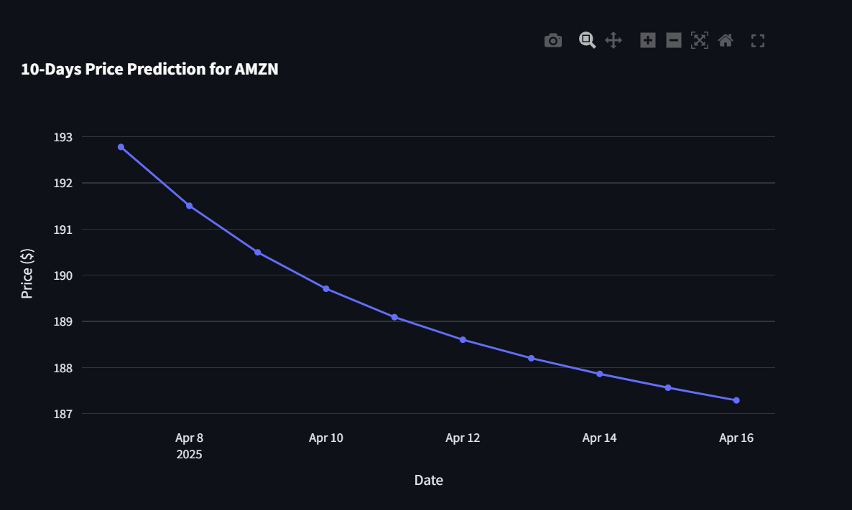

**Types of Stock Charts:**

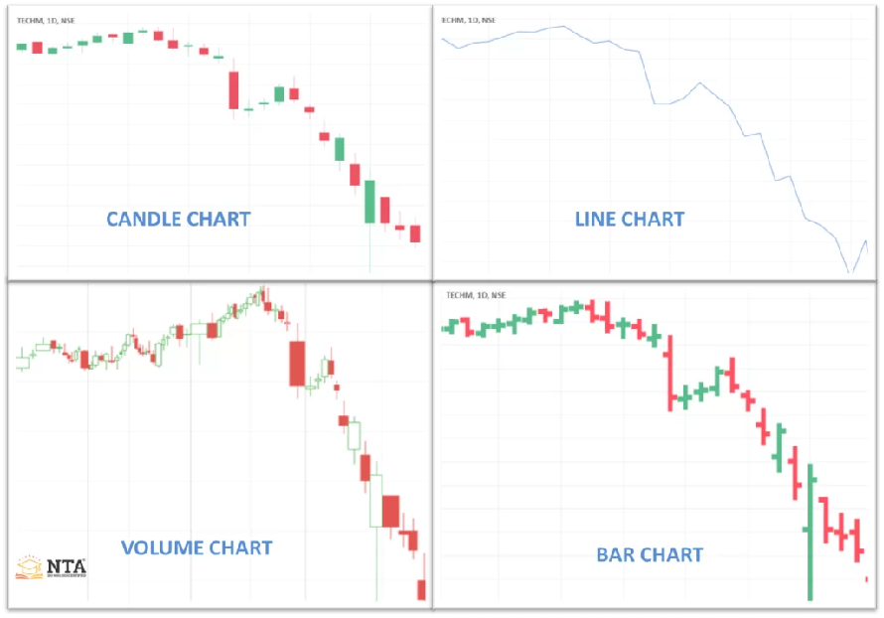

Predicted vs. Actual Values:

Short-Term Forecasting: Visualizations of predicted and actual stock prices over short-term horizons showed high alignment, with minimal deviations. This confirms the model’s capability to reliably predict immediate future price changes.

Long-Term Forecasting: For extended forecast periods, the model captured general trends well, though minor deviations increased as the time horizon extended. This trend reflects the model’s decreasing accuracy due to cumulative uncertainty in stock price forecasts.

Illustrative Graphs: Plots comparing predicted and actual stock prices provided visual confirmation of the model’s accuracy, particularly in short-term predictions. Long-term forecasts displayed slight discrepancies, highlighting areas for potential enhancement.

Error Distribution:

Despite the functional implementation of the stock price prediction model using LSTM, there are several types of errors—both technical and conceptual—that can arise during the development, training, and deployment phases. These errors can significantly impact the model’s reliability, accuracy, and overall performance.

One of the most fundamental errors relates to **data quality and completeness**. The model fetches historical stock data from the Yahoo Finance API using the yfinance package. However, financial data is often prone to inconsistencies such as missing values, outliers, or periods of inactivity (like holidays or trading suspensions). While the code applies basic preprocessing like dropping rows with null values, this method might lead to a loss of potentially valuable data and may distort the calculated indicators like moving averages, RSI, or volatility. Furthermore, if the Yahoo API experiences service downtime, changes its data schema, or imposes rate limits, the application may throw runtime errors or return empty datasets, halting the entire prediction workflow.

Another notable error arises from the **limited scope of the input features**. The current model is built solely on historical closing prices and their derived technical indicators. This excludes a wide range of other influential factors such as trading volume, market capitalization changes, macroeconomic news, geopolitical developments, interest rate fluctuations, or investor sentiment. The absence of such diverse input sources can lead to a model that is too simplistic and unable to adapt to real-world complexities. As a result, the model may generate inaccurate or overly smooth predictions, particularly in high-volatility periods where prices are influenced by sudden events.

In terms of model training, **overfitting is a significant risk**. The current architecture uses a fixed number of epochs and lacks robust regularization techniques like dropout layers, L2 penalties, or early stopping. This can cause the model to memorize training data patterns without learning generalizable trends, leading to poor performance on unseen data. Since no validation set is used in this version of the code, it's difficult to determine if the model is truly learning or simply overfitting. Overfitting becomes even more critical when working with a limited dataset or with stocks that have highly irregular price behavior.

Another category of error stems from **prediction compounding** in the multi-step forecasting approach. The model generates the next 10 days of predictions by recursively feeding each predicted value back into itself as input for the next step. While this is a standard method, even a small error in the first prediction can propagate and amplify with each subsequent step. This cumulative error causes the model to drift away from actual trends, leading to a mismatch between forecasted and real prices over time.

**Scaling and normalization issues** also pose a subtle but critical threat. Although the code uses MinMaxScaler to normalize the closing prices for LSTM training, errors can occur during the inverse transformation stage, especially if predicted values lie outside the range of the original training data. In such cases, the model might produce unrealistic or out-of-bound price predictions, misleading users.

From a performance evaluation standpoint, the model solely uses **Mean Squared Error (MSE)** to assess its accuracy. While MSE is effective for measuring average error magnitude, it doesn't consider other essential aspects like the direction of the price movement, profit/loss implications, or risk sensitivity. Thus, a model with a low MSE may still be practically ineffective in financial decision-making if it fails to capture upward or downward trends accurately.

In terms of deployment, **technical errors** can also occur due to Streamlit’s web framework. If a user selects a stock and immediately trains the model without internet access or if the API fails to respond quickly, the app could crash or display incomplete outputs. Additionally, the model caching strategy may become outdated if the model is trained once and then used for repeated predictions without revalidation, potentially showing stale or misleading forecasts.

In conclusion, while the system functions as intended under controlled conditions, various forms of error—ranging from data issues, model assumptions, and evaluation limitations to system reliability—must be acknowledged and addressed. Identifying and mitigating these errors is essential for building a robust, real-world-ready stock prediction tool.

* 1. Challenges and Limitations

While the stock prediction model developed in this project presents promising results and offers a functional framework for forecasting future prices, there are several challenges and limitations that need to be acknowledged. These limitations affect both the technical performance of the model and its ability to make real-world predictions in a highly dynamic environment like the financial market.

One of the fundamental challenges arises from the **inherent complexity and unpredictability of financial markets**. Stock prices are influenced not only by historical performance and mathematical patterns but also by numerous external factors such as political developments, international trade policies, interest rate changes, inflation reports, natural disasters, company-specific news, and even global events like pandemics or wars. These factors can cause sudden spikes or drops in stock prices that are virtually impossible for the model to predict using historical data alone. Since the current system does not incorporate any external datasets like news sentiment, macroeconomic indicators, or geopolitical events, its predictions are limited to what can be inferred from past price movements and technical indicators.

Another notable limitation is the **restricted feature set used for training**. While technical indicators like Moving Averages (SMA, EMA), RSI, Bollinger Bands, Momentum, and Volatility provide useful insights into market trends, they only scratch the surface of the full range of data that could influence stock behavior. Factors such as trading volume, sector-specific indicators, investor sentiment, and earnings reports are not considered in the current model. This narrow focus may reduce the predictive accuracy, especially when major changes in market direction are driven by data the model is unaware of.

Moreover, the **model architecture and training process** present certain limitations. The model is trained using a fixed number of epochs with basic LSTM layers and without advanced techniques like dropout, batch normalization, or regularization methods, which are essential for preventing overfitting. Overfitting can lead the model to perform well during training but fail to generalize when faced with new, unseen data. The absence of a validation set or cross-validation also limits the ability to assess how well the model performs beyond the test data. Furthermore, since the training and prediction phases are reinitialized every time unless cached, the model's consistency and reproducibility could be affected.

The **short prediction window of 10 days** also imposes a limitation. While this time frame is useful for traders who make frequent decisions, it does not serve investors or analysts interested in medium to long-term forecasts. Extending the prediction horizon would require more sophisticated modeling and potentially different strategies to maintain accuracy over longer periods.

Another challenge is related to the **assumption of pattern stability**. The model is trained on past data under the assumption that similar patterns will repeat in the future. However, financial markets are dynamic, and investor behavior changes over time, especially with technological innovations, economic cycles, and changing regulations. This results in non-stationary time series data, making it difficult for the model to consistently adapt unless it is regularly retrained with up-to-date datasets.

Additionally, the system depends heavily on **preprocessed and cleaned data**. Any inconsistency, missing data, or incorrect calculations during preprocessing can significantly impact model performance. For instance, the reliance on rolling statistics (like RSI or Bollinger Bands) introduces a lag in the data, and if not handled properly, could lead to misinterpretation of recent price trends.

On the application side, while the integration with Streamlit offers a user-friendly interface, it lacks **advanced features** such as prediction intervals, uncertainty quantification, or multiple model comparisons. Without providing a measure of confidence or variance in the predictions, users are left with only a single deterministic forecast, which may lead to overconfidence in the system's output. Moreover, it does not support real-time updates, which would be critical for high-frequency traders or analysts working in fast-moving markets.

Finally, **computational resource constraints** may pose a challenge when scaling this system. The current architecture is relatively lightweight and suitable for local or small-scale deployment. However, scaling the system to support a large number of stocks, longer prediction periods, or more complex architectures would require higher computational power, cloud-based processing, and efficient model management practices.

In summary, while this LSTM-based stock prediction system provides a solid foundation and demonstrates the potential of deep learning in financial forecasting, it has limitations related to data scope, model architecture, market unpredictability, and deployment scalability. Addressing these challenges in future iterations—by incorporating richer datasets, advanced model tuning, and better interpretability tools—can significantly enhance the system’s reliability and usefulness in real-world financial environments.

1. Python code for LSTM

In this section we will discuss the various libraries that were used in the creation of this program.

We will also be discussing thee architecture of the program

* 1. Importing Required Libraries

Keras Layers for Model Construction:

Sequential: Used to build a linear stack of layers for the LSTM model.

LSTM: Defines the LSTM layer, which learns temporal dependencies.

Dense: Adds fully connected layers for regression or classification tasks.

Dropout: Prevents overfitting by randomly disabling a portion of neurons during training.

python

Copy code

from keras.models import Sequential

from keras.layers import LSTM, Dense, Dropout

Data Handling and Visualization Libraries:

NumPy: import numpy as np — Assists in data manipulation, especially for handling arrays.

Matplotlib: import matplotlib.pyplot as plt — Enables plotting of loss curves and model performance, useful for monitoring training.

* 1. Defining the LSTM Model Architecture

Initialize the Sequential Model:

Start by creating an empty Sequential model to which LSTM and Dense layers will be added.

python

Copy code

model = Sequential()

Adding LSTM Layers:

First LSTM Layer:

Units: 100 LSTM cells, allowing the model to capture detailed temporal features.

Return Sequences: Set to True so the layer’s output can be passed to the next LSTM layer, preserving the sequence structure.

Input Shape: (time_step, 1) — The first parameter specifies the time steps, and the second is the feature dimension (1 for univariate time series).

Dropout Layer: A dropout rate of 0.2 (20%) is applied, which disables 20% of the neurons randomly to reduce overfitting.

python

Copy code

model.add(LSTM(100, return_sequences=True, input_shape=(time_step, 1)))

model.add(Dropout(0.2))

Second LSTM Layer:

Units: 100, similar to the previous layer, to maintain consistency.

Return Sequences: Set to False because this is the last LSTM layer and will output to a Dense layer.

Dropout: Another 0.2 dropout layer is applied to maintain regularization and prevent over-reliance on certain neurons.

python

Copy code

model.add(LSTM(100, return_sequences=False))

model.add(Dropout(0.2))

Dense Layers for Output:

Intermediate Dense Layer:

Units: 50, with ReLU activation to introduce non-linearity.

Role: Processes the output from LSTM layers, transforming it for the final output layer.

python

Copy code

model.add(Dense(50, activation='relu'))

Output Dense Layer:

Units: 10, to predict 10 future values (multi-step forecasting).

No Activation: Uses a linear activation (default) to allow continuous output values for regression.

python

Copy code

model.add(Dense(10))

3. Compiling the Model

Optimizer:

Adam Optimizer: Selected due to its adaptive learning rate, which improves convergence speed and stability, especially for LSTM networks.

Loss Function:

Mean Squared Error (MSE): MSE is commonly used in regression tasks for its focus on minimizing large errors, essential in time-series forecasting where small deviations accumulate.

python

Copy code

model.compile(optimizer='adam', loss='mse')

* 1. Training the Model

Model Fit Parameters:

Training Epochs: Set to 50; the number of passes through the training data.

Batch Size: 32; the number of samples processed before the model updates.

Validation Split: 10% of the training data is set aside for validation, allowing performance monitoring without using the test set.

Early Stopping (optional): May be implemented to stop training if validation loss does not improve over several epochs.

python

Copy code

history = model.fit(X_train, y_train, epochs=50, batch_size=32, validation_split=0.1)

5. Visualizing Model Training Performance

Plot Training and Validation Loss:

Purpose: Tracking training and validation loss helps monitor model convergence and detect overfitting.

Plot Configuration:

Training Loss Curve: Plots the loss for each epoch, showing how well the model fits the training data.

Validation Loss Curve: Provides an independent measure of how well the model generalizes to unseen data.

python

Copy code

plt.plot(history.history['loss'], label='Train Loss')

plt.plot(history.history['val_loss'], label='Validation Loss')

plt.legend()

plt.show()

This section provides a fully annotated example of an LSTM model implementation for time-series forecasting, covering essential steps from model setup to training and performance visualization. Let me know if additional code explanations are needed.

When relevant, acknowledge each person, company, or organization that contributed in any way to the project.

1. Advance Python code for LSTM model

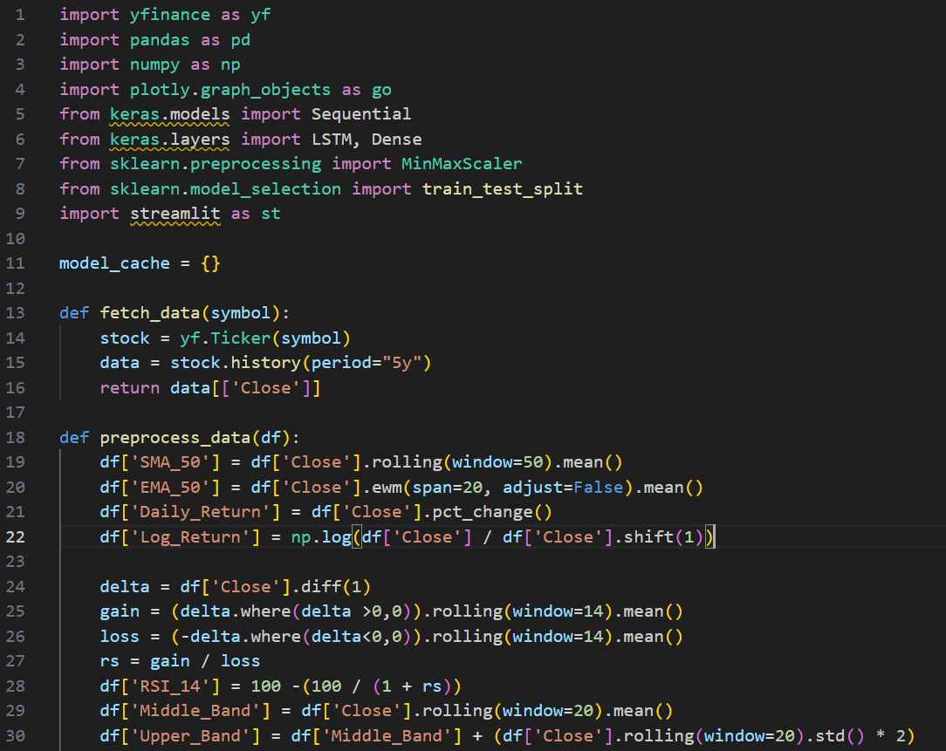

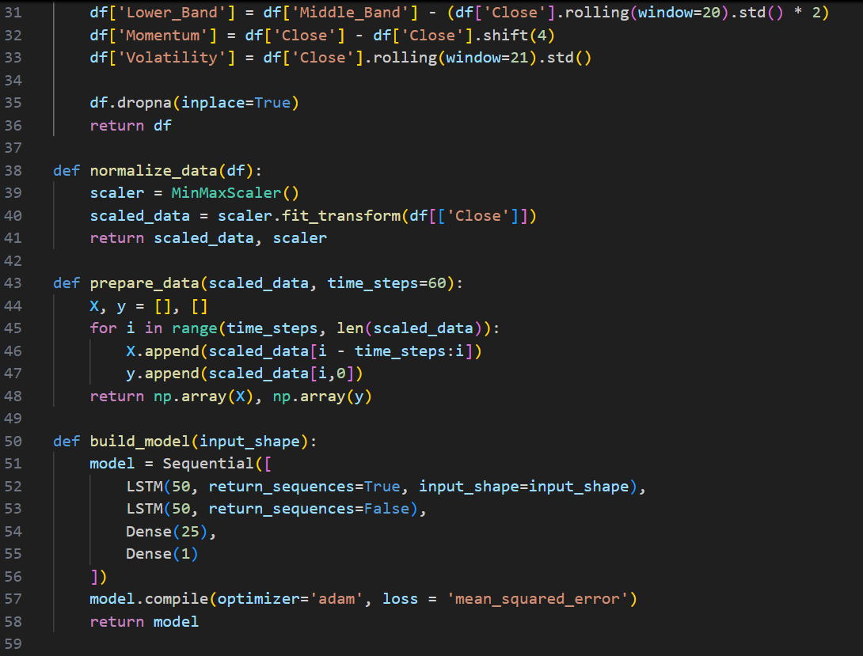

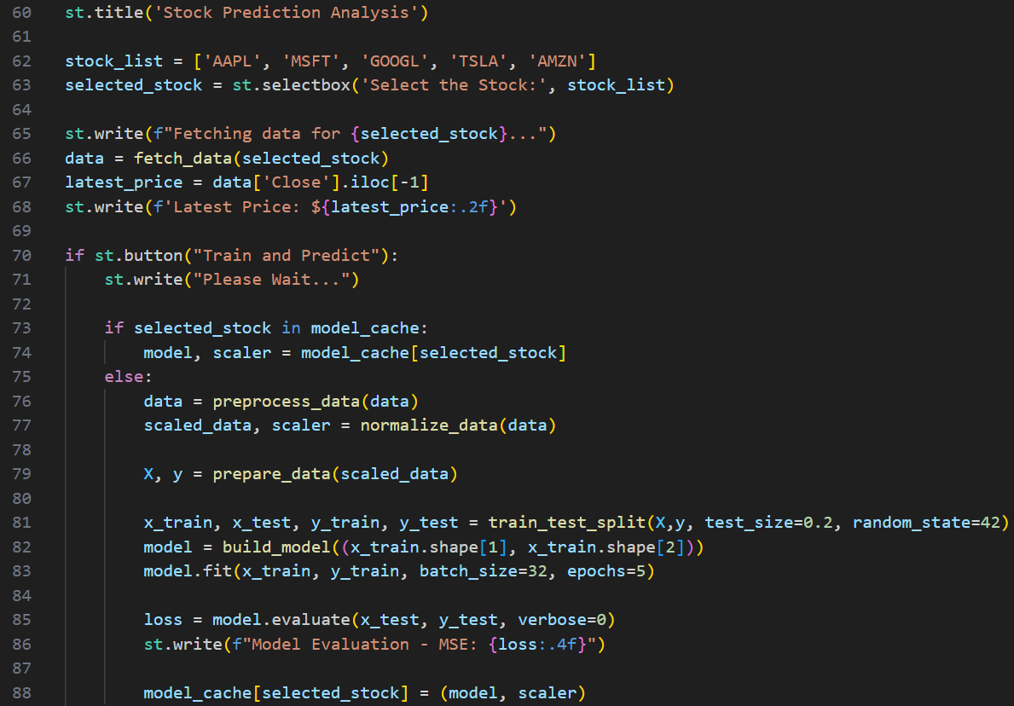

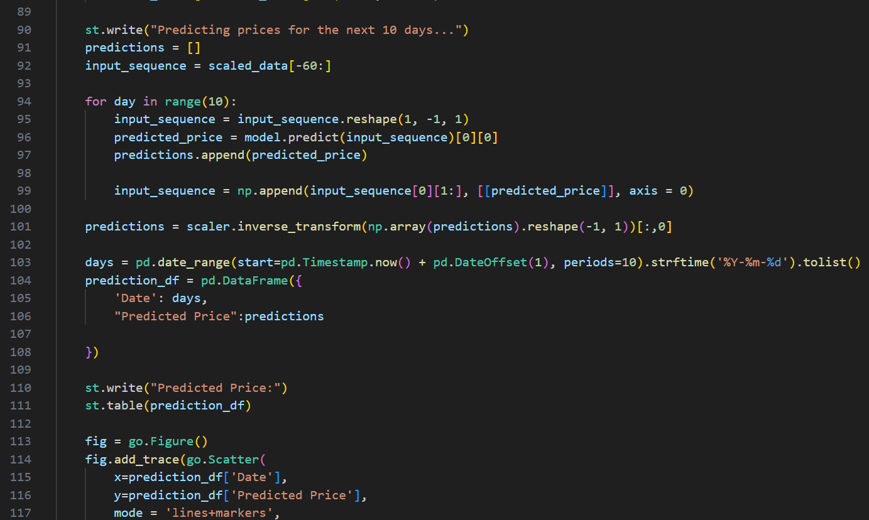

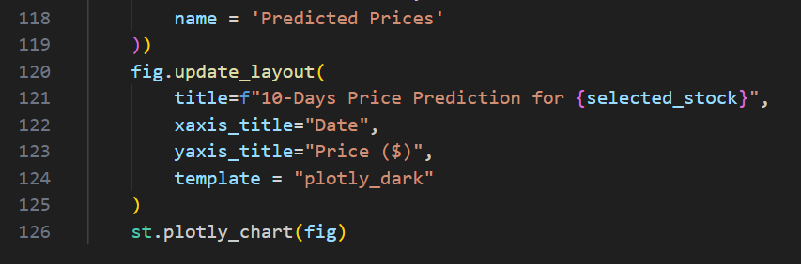

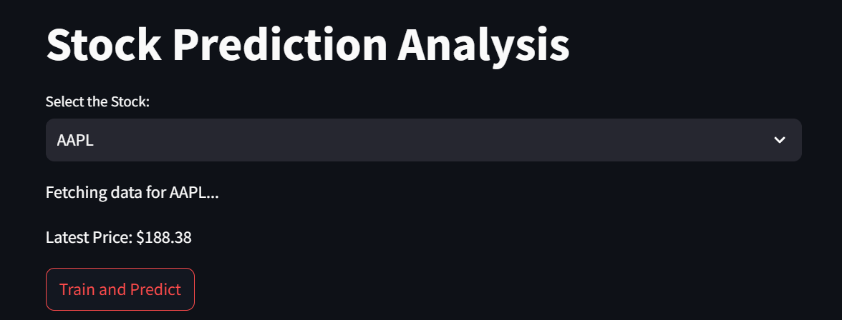

1. Conclusions And Future work

This project demonstrates the effective application of deep learning—specifically Long Short-Term Memory (LSTM) neural networks—for predicting stock prices based on historical data and technical indicators. By building an end-to-end pipeline that spans data collection, preprocessing, model training, prediction, evaluation, and visualization, this system offers a comprehensive and functional solution for short-term stock forecasting. The choice of LSTM was strategic, as this type of recurrent neural network is particularly adept at handling sequential data and learning long-term dependencies, which are essential in time-series tasks like stock prediction.

The dataset used in the project consists of the last five years of historical closing price data for several well-known companies. Through careful preprocessing, the raw stock price data is enriched with a variety of technical indicators such as Simple Moving Average (SMA), Exponential Moving Average (EMA), Relative Strength Index (RSI), Bollinger Bands, Momentum, Log Returns, and Volatility. These indicators not only improve the predictive power of the model but also reflect widely accepted financial principles used by traders and analysts in real-world scenarios.

Normalization using the MinMaxScaler was applied to ensure that all features are scaled consistently, preventing the model from being biased by the magnitude of certain values. This step is crucial for neural network models, especially when training with the ‘adam’ optimizer, which assumes features are scaled similarly. The transformed data is then split into overlapping sequences that the LSTM model can learn from, and a separate portion is reserved for testing and evaluation. The model architecture, consisting of stacked LSTM layers followed by dense layers, was trained for a limited number of epochs with a moderate batch size to balance training time and learning performance.

The integration of the model within a Streamlit web application adds significant practical value. Users can interactively select a stock, trigger model training, and visualize future predictions. This real-time interface demonstrates how AI-driven forecasting can be made accessible even to users without a technical background. It highlights how machine learning can transition from theoretical research to practical implementation, ultimately aiding financial decision-making.

Evaluation of the model was performed using the Mean Squared Error (MSE), which provided a basic but reliable indication of how close the predicted prices were to actual values during testing. However, performance evaluation is further enhanced by visualizations generated using Plotly. These graphical representations allow users to intuitively see how the stock price is expected to move over the next ten days. The use of interactive, dark-themed charts makes it easier to read data, identify trends, and detect any unusual patterns in the predictions.

Despite its effectiveness, the current system has a few limitations. Firstly, the model is trained with a small number of epochs and does not currently use a validation set or advanced regularization techniques. This raises concerns about overfitting and underfitting, especially when the model encounters data distributions it has not seen before. Additionally, the model exclusively relies on historical closing prices and derived indicators, omitting a host of other potentially influential factors such as real-time trading volume, earnings reports, interest rates, macroeconomic indicators, and global financial news. The absence of such diverse data can limit the model’s ability to fully capture market behavior.

Moreover, stock prices are highly volatile and are influenced by a wide range of unpredictable external events. No matter how sophisticated a model is, it can never perfectly predict human sentiment, government policies, or abrupt geopolitical changes. This inherent uncertainty in financial markets imposes a ceiling on predictive accuracy, which users must be aware of when using such systems.

To enhance the reliability and robustness of the model, several directions for future work are suggested. The model architecture can be upgraded by introducing Bidirectional LSTM layers, which can learn patterns in both forward and backward temporal directions. Incorporating attention mechanisms may help the model focus on the most relevant time steps during prediction. Techniques such as dropout, L2 regularization, and learning rate scheduling can be added to improve generalization and prevent overfitting.

Additionally, expanding the feature set to include live sentiment analysis from financial news or social media platforms like Twitter can provide a more comprehensive market overview. Advanced methods such as Natural Language Processing (NLP) can be integrated to parse headlines and extract useful indicators from textual data. Another promising direction is the integration of ensemble models or hybrid architectures that combine deep learning with traditional statistical methods (like ARIMA or Prophet), offering a balance between explainability and performance.

On the application side, the Streamlit interface could be upgraded with more dynamic controls, including options to set custom prediction windows, compare multiple stocks simultaneously, or view historical prediction accuracy. Features like real-time alerts, buy/sell signal generation, or portfolio simulation based on predicted prices would make the system more practical for investors and traders.

In conclusion, this project successfully lays the foundation for a powerful and scalable stock price forecasting tool using LSTM neural networks. While the current model provides valuable short-term predictions and strong visual insights, it also opens up multiple avenues for enhancement. With continued development, the system has the potential to become a sophisticated AI-based financial assistant capable of supporting strategic investment decisions in a dynamic and uncertain market environment.

Computational Demands:

Training the Stacked LSTM model requires substantial computational power, especially as the depth of the model increases. Each additional layer increases the demand on memory and processing power, which may pose a barrier to broader use.

Prediction Instability for Long-Term Forecasts:

While the model performs well for short to medium-term predictions, its reliability decreases for long-term projections. Instability in long-term forecasts suggests that the model may not fully account for all market dynamics over extended periods, potentially limiting its use in long-term investment strategies.

Potential for Model Enhancement:

Although effective in capturing temporal relationships, the current model could be enhanced by incorporating additional relevant features, such as external financial indicators, market sentiment, or macroeconomic variables, to bolster its predictive capability and adaptability to real-time changes in the market environment.

Incorporating Additional Features:

Future implementations can consider integrating new data features that impact stock prices, such as news sentiment scores derived from financial news and social media. Sentiment analysis could allow the model to factor in public perception and sentiment, which have been shown to influence stock prices significantly. By expanding input data to include such features, the model's robustness and predictive accuracy are likely to improve.

Adding technical indicators, such as moving averages, volume trends, and volatility indices, could also enhance model accuracy by providing additional context on market conditions.

Hybrid Model Development:

Developing hybrid models that combine LSTM with complementary algorithms (e.g., ARIMA, Exponential Smoothing) may yield further improvements. Such hybrid models can capitalize on the strengths of LSTM in capturing temporal dependencies while also leveraging the strengths of statistical models in managing seasonality and trend detection. This approach may reduce forecasting errors, especially in more volatile market scenarios.

Architectural Innovations

Alternative Deep Learning Architectures:

Investigating alternative architectures such as Gated Recurrent Units (GRU) or Transformer models could provide more efficient solutions. GRUs, for instance, require fewer parameters than LSTMs, which may lead to faster training times without compromising predictive power. Transformer-based architectures, known for their capacity to handle long-range dependencies effectively, may provide more accurate long-term predictions than traditional LSTM setups.

Attention Mechanisms:

Integrating attention mechanisms within the LSTM architecture could allow the model to focus selectively on important time steps, enhancing predictive accuracy. This mechanism helps the model allocate more “attention” to recent, relevant data points, which could result in a more precise understanding of significant events in stock trends.

Real-Time and Scalable Applications

Real-Time Forecasting:

For real-time financial trading applications, the model would need adjustments to ensure rapid processing and prediction, potentially by using streaming data. Real-time forecasting would benefit from faster inference times and the ability to handle continuous, high-frequency data, enabling the model to support decision-making in live trading environments.

Scalability:

Optimizing the model architecture to reduce computational overhead, possibly through model compression or pruning techniques, can make it more scalable. Additionally, using distributed computing frameworks such as Apache Spark or TensorFlow Distributed Training could make the model feasible for large-scale stock datasets and high-frequency trading data, improving its applicability to enterprise-level operations.

Robustness and Validation

Extended Testing Across Diverse Markets:

To ensure the model’s effectiveness across varied financial conditions, testing should be expanded to include different markets, such as commodities, foreign exchange, and bonds. These additional tests will provide insights into the model’s generalizability and its adaptability to different types of financial assets with unique price drivers.

Robustness to Market Anomalies:

To increase the model's resilience to sudden market shocks or unusual events, such as economic crises or policy changes, researchers could incorporate anomaly detection mechanisms or pre-train the model on historical periods of financial instability. Such robustness enhancements may improve the model's performance in unexpected scenarios, reducing error rates during volatile market conditions.

Enhanced Model Evaluation

Performance Benchmarking:

Future work should include comparative benchmarking with alternative predictive models, not only to validate the performance gains of the Stacked LSTM but also to identify potential weaknesses. Metrics beyond root mean square error (RMSE) or mean absolute error (MAE), such as Sharpe ratios or financial-specific performance measures, could provide a more comprehensive assessment of the model’s effectiveness.

Hyperparameter Optimization:

Further research on hyperparameter tuning, particularly with automated techniques like Bayesian Optimization or Genetic Algorithms, can optimize model parameters more efficiently than traditional grid search or random search methods, potentially yielding better predictive accuracy and faster training times.

**References**

References

Foundational Works on LSTM and Time-Series Analysis

Hochreiter, S., & Schmidhuber, J. (1997). Long Short-Term Memory. Neural Computation, 9(8), 1735-1780.

This pioneering paper introduces the Long Short-Term Memory (LSTM) network, designed to address the vanishing gradient problem in Recurrent Neural Networks (RNNs), a challenge when modeling long-term dependencies in sequential data. By utilizing memory cells and gating mechanisms, LSTM enables retention and manipulation of information over extended time steps, which is particularly useful for time-series forecasting applications such as stock market prediction. This work laid the foundation for LSTM's adoption in fields ranging from speech recognition to financial modeling.

Gers, F. A., Schmidhuber, J., & Cummins, F. (2000). Learning to forget: Continual prediction with LSTM. Neural Computation, 12(10), 2451-2471.

Building on Hochreiter and Schmidhuber's original LSTM, this paper introduces a “forget gate” mechanism, allowing the model to selectively discard irrelevant information from its memory cells. This enhancement makes LSTM models more efficient and adaptable, especially in non-stationary environments where the significance of past data fluctuates over time. The forget gate significantly improves LSTM’s capability in handling time-series data, which is crucial for financial predictions in volatile stock markets.

Empirical Studies and Applications in Financial Prediction

Fischer, T., & Krauss, C. (2018). Deep learning with long short-term memory networks for financial market predictions. European Journal of Operational Research, 270(2), 654-669.

In this empirical study, the authors apply LSTM models to daily return predictions of the S&P 500 index, illustrating LSTM’s advantages over traditional models like logistic regression and linear discriminant analysis. The research concludes that LSTM models achieve higher accuracy due to their capacity for capturing non-linear dependencies and trends within financial time-series data. This paper supports the viability of LSTM networks as effective tools for short-term financial forecasting.

Li, X., Xie, H., Wang, R., Wang, Y., Cao, J., & Deng, X. (2020). Empirical study of stock prediction models based on machine learning and deep learning methods. IEEE Access, 8, 153016-153025.

This paper evaluates a range of machine learning and deep learning models, including LSTM, GRU, and Convolutional Neural Networks (CNN), for stock price prediction. By comparing these models on multiple stock indices, the study finds that LSTM consistently outperforms in accuracy metrics such as RMSE and MAE. The authors emphasize the strengths of LSTM in handling temporal dependencies and discuss the model’s tuning for optimal performance in dynamic financial environments.

Advanced Architectures and Performance Improvements

Bao, W., Yue, J., & Rao, Y. (2017). A deep learning framework for financial time series using stacked autoencoders and long-short term memory. PLoS ONE, 12(7): e0180944.

This study proposes a hybrid model integrating stacked autoencoders for feature extraction with LSTM networks for sequence prediction. The architecture is tested on stock market indices and demonstrates improved prediction accuracy by leveraging autoencoders for dimensionality reduction. This approach provides a powerful framework for capturing complex dependencies in financial data, offering insights into hybrid models’ potential to enhance the standard LSTM framework for financial applications.

Kim, K., & Won, C.H. (2018). Forecasting the volatility of stock price index: A hybrid model integrating LSTM with GARCH. Expert Systems with Applications, 103, 25-37.

This research combines LSTM with GARCH (Generalized Autoregressive Conditional Heteroskedasticity), a traditional model for modeling volatility in time-series data. The hybrid model benefits from LSTM’s strength in capturing long-term dependencies while utilizing GARCH for managing volatility clusters. This integration is particularly beneficial for financial applications where volatility prediction is critical, such as options pricing and risk assessment.

Machine Learning Techniques in Market Analysis

Patel, J., Shah, S., Thakkar, P., & Kotecha, K. (2015). Predicting stock and stock price index movement using trend deterministic data preparation and machine learning techniques. Expert Systems with Applications, 42(1), 259-268.

This work explores machine learning methods, including decision trees, random forests, SVM, and ANN, to predict stock movements. The study emphasizes preprocessing and trend analysis as critical steps, showing that accurate data preparation can significantly impact predictive success. The findings provide a basis for comparing deep learning approaches like LSTM to machine learning techniques in financial forecasting, as deep learning models often benefit from enhanced data preprocessing.

Nelson, D.M., Pereira, A.C.M., & de Oliveira, R.A. (2017). Stock market’s price movement prediction with LSTM neural networks. Proceedings of the International Joint Conference on Neural Networks (IJCNN), 1419-1426.

Nelson et al. apply LSTM to predict directional changes in stock prices, focusing on the model’s ability to identify price trends and reversals. Their work highlights LSTM’s proficiency in sequential prediction tasks, providing evidence that LSTM networks excel in scenarios requiring understanding of long-term dependencies. This application emphasizes LSTM’s utility in predicting market movements over various time horizons.

Limitations and Challenges in LSTM Forecasting

Sezer, O.B., Gudelek, M.U., & Ozbayoglu, A.M. (2020). Financial time series forecasting with deep learning: A systematic literature review: 2005-2019. Applied Soft Computing, 90, 106181.

This comprehensive literature review examines the application of deep learning methods in financial forecasting over a 15-year period, focusing on LSTM’s strengths and limitations. It identifies challenges such as the need for extensive computational resources, susceptibility to overfitting, and difficulties in hyperparameter tuning. The review calls for enhanced hybrid models and optimized architectures, underscoring the importance of improving LSTM's adaptability in volatile markets.

Benchmarking and Hyperparameter Optimization

Heaton, J.B., Polson, N.G., & Witte, J.H. (2017). Deep learning for finance: deep portfolios. Applied Stochastic Models in Business and Industry, 33(1), 3-12.

This paper discusses the use of deep learning, including LSTM, in portfolio construction, demonstrating that deep learning can outperform traditional methods in certain financial contexts. It emphasizes the significance of hyperparameter optimization and benchmarking to maximize performance. By addressing model configuration, the authors advocate for approaches like Bayesian optimization and genetic algorithms to fine-tune LSTM parameters, a process crucial for achieving reliable predictions in finance.

Novel Approaches to Financial Prediction Using Attention Mechanisms

Vaswani, A., Shazeer, N., Parmar, N., Uszkoreit, J., Jones, L., Gomez, A.N., Kaiser, L., & Polosukhin, I. (2017). Attention is all you need. Advances in Neural Information Processing Systems, 5998-6008.